Radium Sorption to Iron (hydr)oxides, Pyrite, and Montmorillonite: Implications for Mobility

Michael A. Chen and Benjamin D. Kocar*

Dept. of Civil and Environmental Engineering,

Massachusetts Institute of Technology

*Corresponding author, kocar@mit.edu

**Abstract**

Radium (Ra) is a radioactive element commonly found within soils, sediments and natural waters. Elevated Ra activities arising through natural and anthropogenic processes pose a threat to groundwater resources and human health, and Ra isotope ratios are used to decipher groundwater movement, estimate submarine discharge flux, and fingerprint contamination associated with hydraulic fracturing operations. Although adsorption to metal (hydr)oxides and certain clay minerals is well established as a dominant mechanism controlling Ra transport and retention, the extent of Ra sorption to other minerals and under variable environmental conditions (e.g. pH and salinity) is limited. Accordingly, we present results of sorption studies and surface complexation modeling (SCM) of Ra to ferrihydrite, goethite, montmorillonite, and pyrite, for a range of pH values and common background cations. Radium sorption to all substrates is observed under geochemical conditions considered, but varies according to mineral, solution pH and specific competing cations. Literature derived SCMs for Ra sorption were fitted to match either sorption impacts due to pH or different background cations, but the resultant Ra-surface complex K values varied as much as 9 log K units. These discrepancies arise from missing constants for competing cations or incomplete descriptions of Ra sorption to these minerals’ surfaces. Nevertheless, SCM results provide a quantitative comparison between Ra adsorption to different soil and aquifer minerals and under varying geochemical conditions, and suggest that typical means of describing and predicting Ra transport (i.e. distribution coefficients) may not be sufficient to explain and predict spatio-temporal distributions of Ra in subsurface environments.

**Table of Contents (TOC) /Abstract Art**

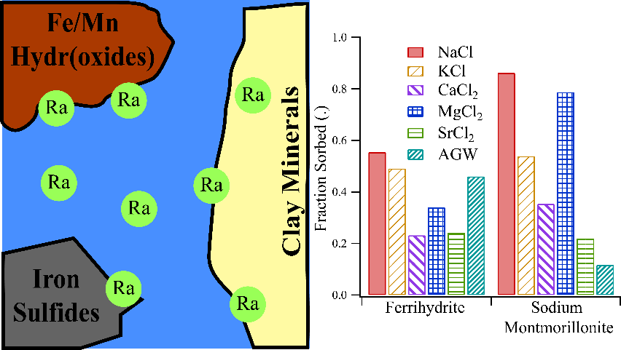

**Introduction**

Chronic ingestion and inhalation of radioactive materials, including radium (Ra) and radon (Rd), represents an ongoing threat to human health worldwide.1 Of these, Ra is ubiquitous in soils, aquifers, and natural waters owing to the radioactive decay of primordial 235U, 238U, and 232Th, and often accounts for the dominant fraction of total radiation found in groundwater. All isotopes of Ra are unstable, and four (223Ra, 224Ra, 226Ra, and 228Ra) possess half-lives sufficient to persist within environmental systems and present a risk for human exposure. Moreover, 226Ra (half-life of 1600 years) is the parent radionuclide of 222Rn; chronic inhalation of 222Rn increases risk of lung cancer.2 Hence, geochemical controls on Ra mobility are directly tied to the mobility and accumulation of Rn within soil-sedimentary systems.

Several geochemical processes impart overarching controls on Ra within soils and aquifers. Alpha-recoil, the ejection of daughter radionuclides from soil and sedimentary minerals into adjacent porewater, is the primary process sourcing Ra to groundwater. Ongoing alpha recoil progressively elevates porewater Ra activities until hydrologic flushing removes the equilibrating solution, or Ra achieves secular equilibrium with its parent radionuclides. Most aquifer systems contain low (e.g. U, Th, <5 mg/kg) but adequate parent radionuclide and sufficiently favorable hydrological conditions to facilitate delivery of measurable Ra to solution.3 In a recent USGS study, 3% of groundwater samples (n=1270) within 7 of 15 principal US aquifers exceeded the USEPA limit for total Ra of 0.185 Bq/L.4 Further, high levels of Ra are often present with deeper formations, particularly shales, where low groundwater flux yield potentially hazardous activities (0.102-343 Bq/L).5 These naturally elevated Ra bearing formations are prevalent in some parts of the US (PA, WY, TX) and abroad (Middle East, etc.).6,7 Anthropogenic activities, including uranium mining and hydraulic fracturing, can redistribute Ra and other constituents of naturally occurring radioactive materials (NORM), posing potential hazards to populations nearby affected soils, surface waters, and aquifers.

Under environmental conditions, Ra is not redox active, and its solution speciation is dominated by free Ra2+(aq) across a wide range of chemical conditions (e.g. pH and salinity). Weak complexes with carbonate, sulfate, and chloride are observed, but these solution species are only important at extremely acidic or basic pH values and when ligand activities exceed environmental relevance.8 The Ra2+ ion participates in several geochemical reactions that constrain (or enhance) its presence in natural waters, resulting in non-conservative transport in aquifers. Sorption to soil and aquifer solids is generally regarded as the dominant process controlling Ra solubility of in many soil and groundwater systems.9,10 Alternatively, co-precipitation of Ra with Ba and Sr sulfates can rapidly scavenge Ra from solution, but depends on elevated (~1 mM) levels of Ba, Sr, and SO42- to proceed, and typically are kinetically limited in natural waters.11

Soil and sedimentary minerals known to sorb appreciable quantities of Ra include metal (hydr)oxides and 2:1 clays with an exchangeable interlayer. However, previous data are primarily derived from Ra sorption experiments using mineralogically heterogeneous soil and sedimentary solids, and fewer studies have examined Ra sorption to single minerals with simple electrolyte solutions. This has generated a wealth of reported Kd values for Ra sorption to different soil and aquifer materials, however, these are of limited use for deciphering the importance of specific minerals with respect to Ra sorption, and under variable geochemical conditions, especially when competing cations are present in solution. It is well established that increasing ionic strength will drive release of sorbed Ra into solution, but there are few studies that examine the impact of specific cations on this release.11 11 There is a paucity of data regarding Ra adsorption to redox-sensitive minerals found under suboxic or reducing conditions. These solids, including metal sulfides such as pyrite, may be particularly important within soil and aquifer systems derived from shale, and also within marine sediments—including those which intercept submarine groundwater discharge that carry naturally occurring Ra.

Improved knowledge of Ra sorption to common soil and sedimentary solids and with different background solutions is required to decipher Ra mobility and predict total activities within natural waters. This understanding can also aid in interpreting Ra isotopic ratios used to trace sources of Ra and understand groundwater movement. The objectives of this study were to therefore: 1) examine and compare low-activity Ra adsorption to ferrihydrite, goethite, and Na-montmorillonite—minerals known or inferred to control Ra transport over a range of solution conditions found in soils and aquifers—and pyrite, a mineral commonly found within reduced and anoxic soils and sediments, 2) examine the impact of individual and mixtures of cations on Ra sorption, 3) evaluate the accuracy of common metal ion surface complexation models (SCMs) for predicting Ra sorption to these materials for differing solution conditions, and 4) use SCMs as a quantitative means for comparing the extent of Ra adsorption between different minerals and geochemical conditions. Generally, we find the greatest extent of Ra sorption to occur with sodium montmorillonite at low ionic strength and over a wide range of pH values. However, Ra sorption to Na-montmorillonite is extremely sensitive to both total ionic strength, and specific cations in solution with Ra. In contrast, pH controls sorption iron (hydr)oxides, with increasing pH enhancing sorption, but background cations do not affect Ra sorption as strongly as with sodium montmorillonite. Appreciable quantities of Ra sorb to pyrite over all tested solution conditions, and exhibited minimal sensitivity to solution composition, with the exception of treatments using high ionic strength solutions. Lastly, we find that common SCM thermodynamic constants are useful for providing a quantitative comparison of Ra sorption to different minerals under similar geochemical conditions, but are poor predictors of Ra adsorption when conditions (e.g. pH, ionic strength) are altered.

**Materials and Methods**

Dissolved 226Ra stock in 3% HCl was provided by the MIT Environmental, Health, and Safety office and used for all experiments. A ferrihydrite slurry and goethite powder were prepared using standard methods and added to the experiments.12 14 Powdered calcium montmorillonite STX-1b was ordered from The Clay Minerals Society (clays.org), re-equilibrated with sodium chloride to allow for closer comparisons to previous studies of Ra sorption to Na-montmorillonites, and then cleaned of carbonates using standardized techniques.13 Pyrite was ordered from Ward’s Science (www.wardsci.com), ground using mortar and pestle, passed through sieves to select for 45-250 µm particles, and transferred to an anoxic glove bag (H2: 2% , N2: 98%, O2: < 1 ppm). It was then washed in 6 N HCl overnight to dissolve any oxidized coatings, rinsed with deoxygenated DI water three times to remove residual acid, and dried anoxically at room temperature. The composition of pyrite, ferrihydrite and goethite was confirmed using XRD, and surface area was measured for all minerals using BET (table S1). Further information regarding mineral preparation is found in the supporting information.

All experiments were conducted using serum vials (200 mL) filled with 100 mL of background solution, 30 mg of a single mineral (except for the case of pyrite, where 40 mg was used), and 3-320 Bq of 226Ra stock. Isotherms were performed at pH 3, 5, 7, or 9 +/- 0.05 using 10 mM NaCl stock as the background solution. The impact of different background cations on Ra adsorption to ferrihydrite, goethite, pyrite, and sodium montmorillonite was elucidated at pH 7 +/- 0.05 using 10 mM CaCl2, MgCl2, KCl, SrCl2, or a 10 meq/L ionic strength artificial groundwater (AGW) (table S2). The impact of increasing ionic strength on Ra sorption to these minerals was examined with a pH 7 +/- 0.05, 100 meq/L artificial brackish water (ABW) and 800 meq/L artificial seawater (ASW) (table S2). Experiments using pyrite were performed in a sub-oxic (<1 ppm O2­) glove bag, and all solutions were purged with N2 prior to placement in the anoxic chamber. For all experiments, an auto-titrator was used to assist pH adjustment, and bottles were sealed with a thick butyl stopper. Bottles were shaken for 24 hours to allow sufficient time for sorption equilibrium.14 12 A kinetic study of Ra adsorption to montmorillonite confirmed 24 hours is sufficient to achieve equilibrium (SI). pH was readjusted after equilibration if necessary; details on this process are in the supporting information. Acid (HCl) and base (NaOH) volume additions did not exceed 5% of the original solution-slurry volume. Once re-titration and re-equilibration were complete, samples were filtered using 0.22 µm PES filters, which did not sorb significant quantities of Ra. Experimental error was quantified by measuring the standard deviation of triplicates for each data point.

**Analytical Techniques.** Solutions of Ra were quantified using scintillation counting. Up to 10 mL of sample were mixed with 10 mL of Ultima Gold XR (Perkin Elmer) and sealed for 30 days to allow 226Ra to reach secular equilibrium with its daughter products. The equilibrated samples were then counted using a Beckman Coulter LS 6500 scintillation counter, and the resulting counts were compared to a calibration curve of similarly prepared 226Ra standards (see SI) to determine solution activities.

**Surface Complexation Modeling.** Radium interaction with mineral surfaces was modeled through mineral specific surface complexation models implemented in PHREEQC.15 The IPHREEQC COM module was used in conjunction with a python script to easily enable multiple realizations of the SCM for fitting.16 The naturally low levels of Ra in the environment combined with the significant radiotoxicity of Ra have hindered the development of spectroscopically informed models of Ra-specific SCMs. Thus, in all cases, a double diffuse layer formulation is used for SCM, following Dzombak and Morel’s generalized two layer model, except for pyrite, where fitting attempts were unsuccessful.17 17Ra surface complexes were derived from group II cation SCM reactions published in previous studies, and then fit experimental data. These models were supplemented with adsorption reactions for competing ions, whose constants were directly taken from literature values or derived from linear free energy relationships posed in previous studies.17–2412,17–19 Model fits to data were achieved through varying the thermodynamic constant for each Ra (ad)sorption reaction. Fitting was performed on isotherm data and data from experiments testing the effects of competing cations on Ra sorption; thermodynamic constants developed for each set of experiments were then compared. Details for fitting SCMs, discussion of the choices of SCMs, and the different pyrite SCMs tried are found in the supporting information.

**Results and Discussion**

**Sorption isotherms.** All isotherms using 10 mM NaCl were linear in the range of activities considered (figure S1), and thus each were fitted to a line using a least squares method, whose slope corresponds to the (mass normalized) Kd for that isotherm (figure 1a). Sorption to both iron (hydr)oxides show a strong dependence on pH, with ferrihydrite showing greater sorption across all pH values compared to goethite, and the extent of sorption increasing with increasing pH for both iron (hydr)oxides. Previous studies of Ra sorption to ferrihydrite and goethite have also reported these differences, and suggested the structural differences between these two minerals led to differences in surface area that impacted Ra sorption.14 Here, those differences can explain some of the variation when comparing the extent of Ra sorption for goethite and ferrihydrite sorption, with ferrihydrite having nearly twice the surface area of goethite. Fitted Kd values were normalized by the measured surface area to derive a Ksa (figure 1b), showing that at circumneutral pH, goethite and ferrihydrite have close Ksa values, however, at more extreme values (pH = 3 and pH = 9) ferrihydrite demonstrates an appreciably larger extent of sorption compared to goethite. That the discrepancy persists after surface area normalization indicates additional mineralogical differences, likely related to surface chemistry or mineral specific electrostatics. For example, the different Fe coordinations (tetrahedral and octahedral) found in ferrihydrite could result in larger surface site affinity for Ra2+ as compared to the single octahedral coordination environment of Fe atoms in goethite.25,26 However, more investigation is required. Two studies have reported isotherm data for Ra sorption to ferrihydrite.11,14 11,12The K­d found in our study is larger than found in those studies by at least a factor of 2 (SI for values and comparison), but was also performed at lower background ionic strength (here, 10 mM NaCl, others, 100-500 mM) and higher mineral surface area (here, 382.9 m2/g, others, ~250 m2/g).9 Ksa values were fairly close to those reported in other studies, with higher background solution ionic strength matching with smaller Ksa, consistent with previously reported results that increasing ionic strength decreased Ra sorption to iron oxides.11

Results for mass normalized (Kd) and surface area normalized (Ksa) sorption of Ra onto sodium montmorillonite are plotted in figures 1 and 2. With the exception of ferrihydrite at pH 9, the total extent of sorption to montmorillonite is larger than iron (hydr)oxides over all pH values regardless of normalization. Also, a comparatively weaker pH dependence is observed for montmorillonite sorption. This result implies that the dominant mechanism controlling montmorillonite sorption is not complexation with pH dependent surface (edge) functional groups, but rather exchange of Ra with clay interlayer cations. Unlike with the iron (hydr)oxides, the Kd and K­sa values were larger by nearly an order of magnitude compared to previous studies, in spite of similar background solution composition.13,2715,20 Those used a high solid-solution ratio (3000-50000 mg solid/L) but resulted in less sorption compared to the sorption results found here, which used only a 300 mg/L solid-solution ratio.15,21 The CEC of the clay used here (84.4 meq/100g, clay minerals society) falls within the range of those other studies (76.4-120 meq/100g), as does the surface area (50.2 m2/g, table S1 compared to 31.82-97.42 m2/g from clay minerals society).20 Given the similar experimental conditions, one would expect that Kd values would also be similar. This discrepancy may be explained by the mineralogical differences that are not readily captured by these common sorption parameters, as this study and the previous studies each used a different type of montmorillonite (here, STx-1b, Tamamura, SWy-2, Ames, SAz-1). For these different clays, structural variations driven by differences in mineral composition and isomorphic substitutions can drive differences in Ra affinity for surface and interlayer sites. Thus, one possible explanation for the discrepancies in K­d/Ksa values is that the clay minerals society reported structure for the clay used here may have fewer isomorphic substitutions that readily compete with Ra (Mn, Mg), resulting in Ra more readily exchanging with interlayer cations.20 Further investigation, however, is necessary to elucidate how specific observable differences (in structure, composition, etc.) between clays result in variations can impact Ra sorption.

Pyrite showed low, but appreciable sorption over all pH values, and weak dependence on pH (figure 1), with similar sorption to some iron (hydr)oxides at acidic pH values. Unexpectedly, surface area normalized sorption isotherms show that pyrite has the largest sorption of all the minerals considered here (figure 2). There is very little existing data examining the sorption of Ra to any reduced iron solid. A previous study demonstrated that strontium (Sr), which possesses analogous geochemical characteristics as Ra, did not sorb extensively to pyrite22;28 In contrast, a variety of experimental and spectroscopic techniques have been used to study redox active metal ions sorption to the pyrite surface, which often includes redox reactions between the metal ion and pyrite surface groups.28–3322–27 The results of these studies imply that redox active metal ions or trace quantities of dissolved oxygen in solutions with Ra may alter the pyrite surface, consequentially diminishing or enhancing Ra sorption depending on the Fe (hydr)oxide phase formed. However, we find no evidence of oxic pyrite alteration in our experiments, and use exceedingly low Ra concentrations (0.06-31 nmoles per experiment) which preclude using analytical methods for examining the coordination environment of adsorbed Ra. The difference in reported Sr sorption and Ra sorption may instead by driven by natural pyrite impurities, which result in isomorphic substitutions that change mineral surface charge, thus impacting Ra sorption affinity for the pyrite surface. Further study of the pyrite surface in anoxic and suboxic settings is necessary to constrain pyrite’s control on Ra transport. Authigenic pyrite found in natural shales and estuarine settings may show enhanced sorption compared to that found here, as they may have larger surface area than the crushed pyrite here.

**Background cation controls on Ra sorption.** Experiments using different background electrolytes, but with similar ionic strength, initial concentration of Ra (60-70 Bq total activity) and pH (7.0) illustrate notable deviations from Ra adsorption trends observed using NaCl (Figure 2). In particular, sodium montmorillonite shows large changes in Ra retention in the presence of different competing cations. Notably, the use of the 10 mM ionic strength AGW altered trends originally observed for Ra isotherms using a 10 mM NaCl background, with ferrihydrite having a larger sorption extent compared to the montmorillonite. This is likely a result of background cation competition for interlayer exchange sites in the clay, which were not present in the iron oxides. Divalent cations tended to reduce Ra sorption compared to monovalent cations, as did heavier ions, with strontium resulting in minimal Ra sorption across all minerals. Ra sorption to pyrite showed little sensitivity to cation type Overall, less adsorption of Ra to all substrates is observed in experiments in which AGW is used; hence, sorption data from experiments using background solutions dominated by a single monovalent cation such as sodium may overestimate the extent of Ra sorption compared to natural solutions harboring a diversity of mono and multi-valent cations, and shifts in groundwater ion composition (i.e. driven by mixing of different source waters) could alter Ra sorption to aquifer materials. This is particularly relevant for hydraulic fracturing systems where injected groundwaters tend to have a different ionic composition compared to the natural formation brine, and could be tuned to reduce Ra concentrations in the resulting produced water.

Experiments to examine the influence of increasing ionic strength were also performed, using the same ratio of cations used in the AGW (table S2), but with increasing total ionic strength (figure 3). Specifically, “brackish” (100 meq/L) and “seawater” (800 meq/L) ionic strengths were targeted (pH 7.0). As with experiments using different electrolyte compositions, the greatest decrease in Ra adsorption occurred in treatments using sodium montmorillonite; sorption decreased 80 percentage points as compared to 10 mM NaCl. In contrast, high ionic strength solutions imparted less effect on Ra adsorption to Fe (hydr)oxides—Ra sorption to goethite and ferrihydrite in ASW only decreased 8 and 54 percentage points compared to 10 mM NaCl, respectively. These results illustrate that clays possessing an exchangeable interlayer harbor appreciable Ra under low ionic strength conditions, but iron (hydr)oxides may control radium sorption across shifting solution conditions such as those found within intertidal zones, etc. Nevertheless, all minerals experienced decreases in Ra sorption with increasing ionic strength, suggesting the increased presence of competing cations will reduce Ra sorption overall, even at trace levels. This is consistent with previous studies of Ra sorption in saline conditions, which also found similar results for iron (hydr)oxide phases.11 11 However, it is important to note that some Ra is still retained by these surfaces even under high ionic strength conditions, suggesting that soil-sedimentary solids may serve as persistent sources or sinks of Ra despite large shifts in solution composition.

**Surface Complexation Modeling.** For ferrihydrite and goethite, fits of isotherm data to the SCM (see table 1 for Ra surface complexes considered and SI for the full set of reactions considered) produced good visual fits. When these isotherm-derived log K values were used to simulate experiments with different background cations, the fits were also reasonable (root mean squared error (RMSE) of Ra fraction sorbed: 0.31 and 0.16 for ferrihydrite and goethite respectively). Iteratively fitting iron (hydr)oxide Ra log K values to the different background electrolyte experiments resulted in improved fits to the background cation data (RMSE: 0.16 and 0.10) (table 1), but produced worse visual fits for the isotherm data. While the fits are reasonable to each data set, the corresponding log K values for isotherm and background electrolyte derived log Ks varied at least by 1 log unit, and often many more, suggesting the model fits have only limited predictive power when extended to natural background solutions and minerals.

Surface complexation modeling of Ra sorption to montmorillonite was achieved through inclusion of an inter-layer exchange reaction, which was necessary to reproduce the high amount of Ra sorption observed at low pH values. Isotherm fitted log K values and background cation fitted K values had poor background cation RMSEs and isotherm visual fits as compared to the iron (hydr)oxides (table 1). The use of literature selectivity coefficients for the competing cations is incorrect, as they are specifically derived for trace levels of competing cation.23 Used as is, they will incorrectly predict competition between Ra and other competing cations because they do not account for changes in the activity of clay exchange sites as the competing cation exchanges with Na in the clay inter-layers, explaining the poor fits observed. Removal of these selectivity coefficients from this model however, resulted in overprediction of Ra sorption compared to experimental results and worse fits, since the models did not consider competitive exchange between Ra and the various background cations considered. Nevertheless, the necessary inclusion of an exchange reaction illustrates that Ra sorption to sodium montmorillonite is mechanistically distinct from other solids (e.g. Fe (hydr)oxides), resulting in differential Ra sorption trends across solution conditions. 2:1 clay minerals may retain Ra under conditions where other minerals act as poor sorbents (e.g. low pH), but Ra sorption to those minerals is more prone to alteration when solution cation composition is varied.

**Implications for radium mobility in soils, sediments and aquifers.** Results presented here illustrate the dominant role of mineralogy on the retention, release, and transport of Ra in soil and sedimentary systems. Poorly crystalline iron (hydr)oxides (e.g. ferrihydrite) will act as greater Ra sorbents than goethite within variably saturated soils and sediments, whereas pyrite may retain Ra within deep shale aquifers or permanently anoxic freshwater and sediments. Under fixed, circumneutral pH and background electrolyte composition, the extent of Ra sorption to each mineral is appreciably different, hence mineralogical transformation through processes including Ostwald ripening (e.g. ferrihydrite transformation to goethite) or reduction-oxidation (pyrite oxidation to secondary iron (hydr)oxides)) are expected alter Ra mobility and fate. Moreover, variations in solution chemistry altered observed Ra sorption trends differently for each mineral, likely reflecting known or inferred mechanisms of Ra-solid association. For example, sodium montmorillonite retains more Ra than ferrihydrite under low-ionic strength and pH conditions, but this trend is reversed with increased activity of divalent cations that compete with Ra for interlayer sites through mass action (and greater selectivity relative to monovalent cations) compared to competition with Ra complexed with ferrihydrite surface sites. These mechanisms are partially validated through SCM, which are used to successfully describe Ra sorption to Fe (hydr)oxide surfaces and sodium montmorillonite edge and inter-layer sites, and which also provide a means to quantitatively compare Ra sorption between minerals across a range of geochemical conditions. However, discrepancies in Log K values obtained for Ra sorption under different solution conditions, and difficulties associated with modeling Ra sorption to pyrite illustrate that laboratory derived SCM reaction constants will not accurately describe or predict Ra sorption and reactive transport within (bio)geochemically complex systems. Additionally, selectivity and reaction constants for key competing cations (e.g. Na+, K+) that can be used in SCMs were not found in the literature. Further analytical investigation of Ra interactions with minerals and mineral surfaces is therefore required to improve mechanistic descriptions used in modeling efforts, particularly those used for describing Ra transport within soil and sedimentary systems with fluctuating geochemical conditions driven by tidal activity, variable groundwater flow, and the industrial extraction and processing of deep groundwater generated from hydraulic fracturing and hydrocarbon extraction operations.

**Acknowledgements**

The authors thank Mitch Galanek, MIT Environmental Health and Safety, for supplying 226Ra stock solutions, radiation protection equipment and safety expertise, Neha Mehta (MIT) for her assistance with scintillation/gamma counting, Tiffany Wang (MIT) for assisting with isotherm experiments, and Dara Hok of the Kim Lab (Chapman University) for performing BET analysis. This work was partially supported by the MIT energy initiative (MITEI). The authors declare no competing financial interest.

**Supporting Information**

Additional descriptions of methods and results are presented in supporting information.

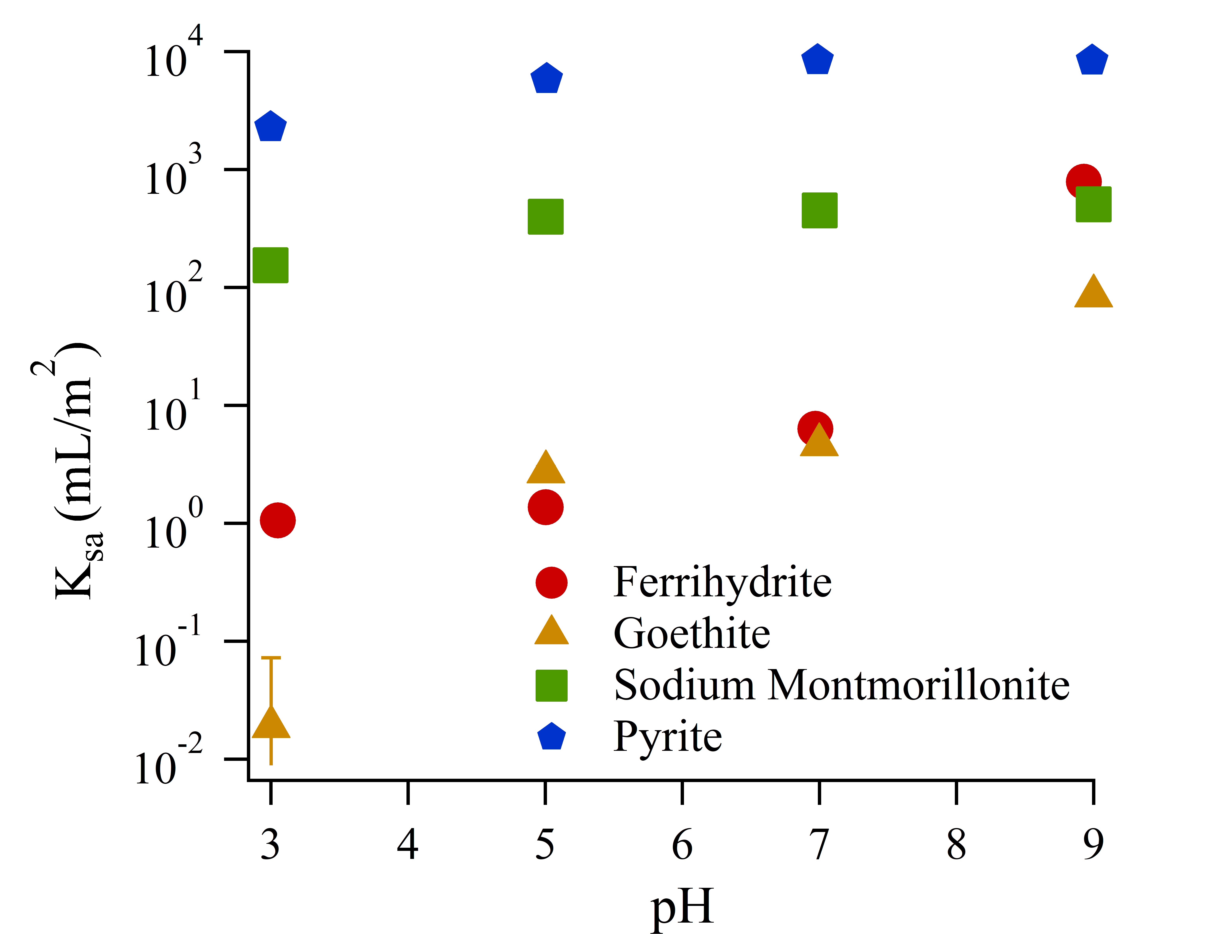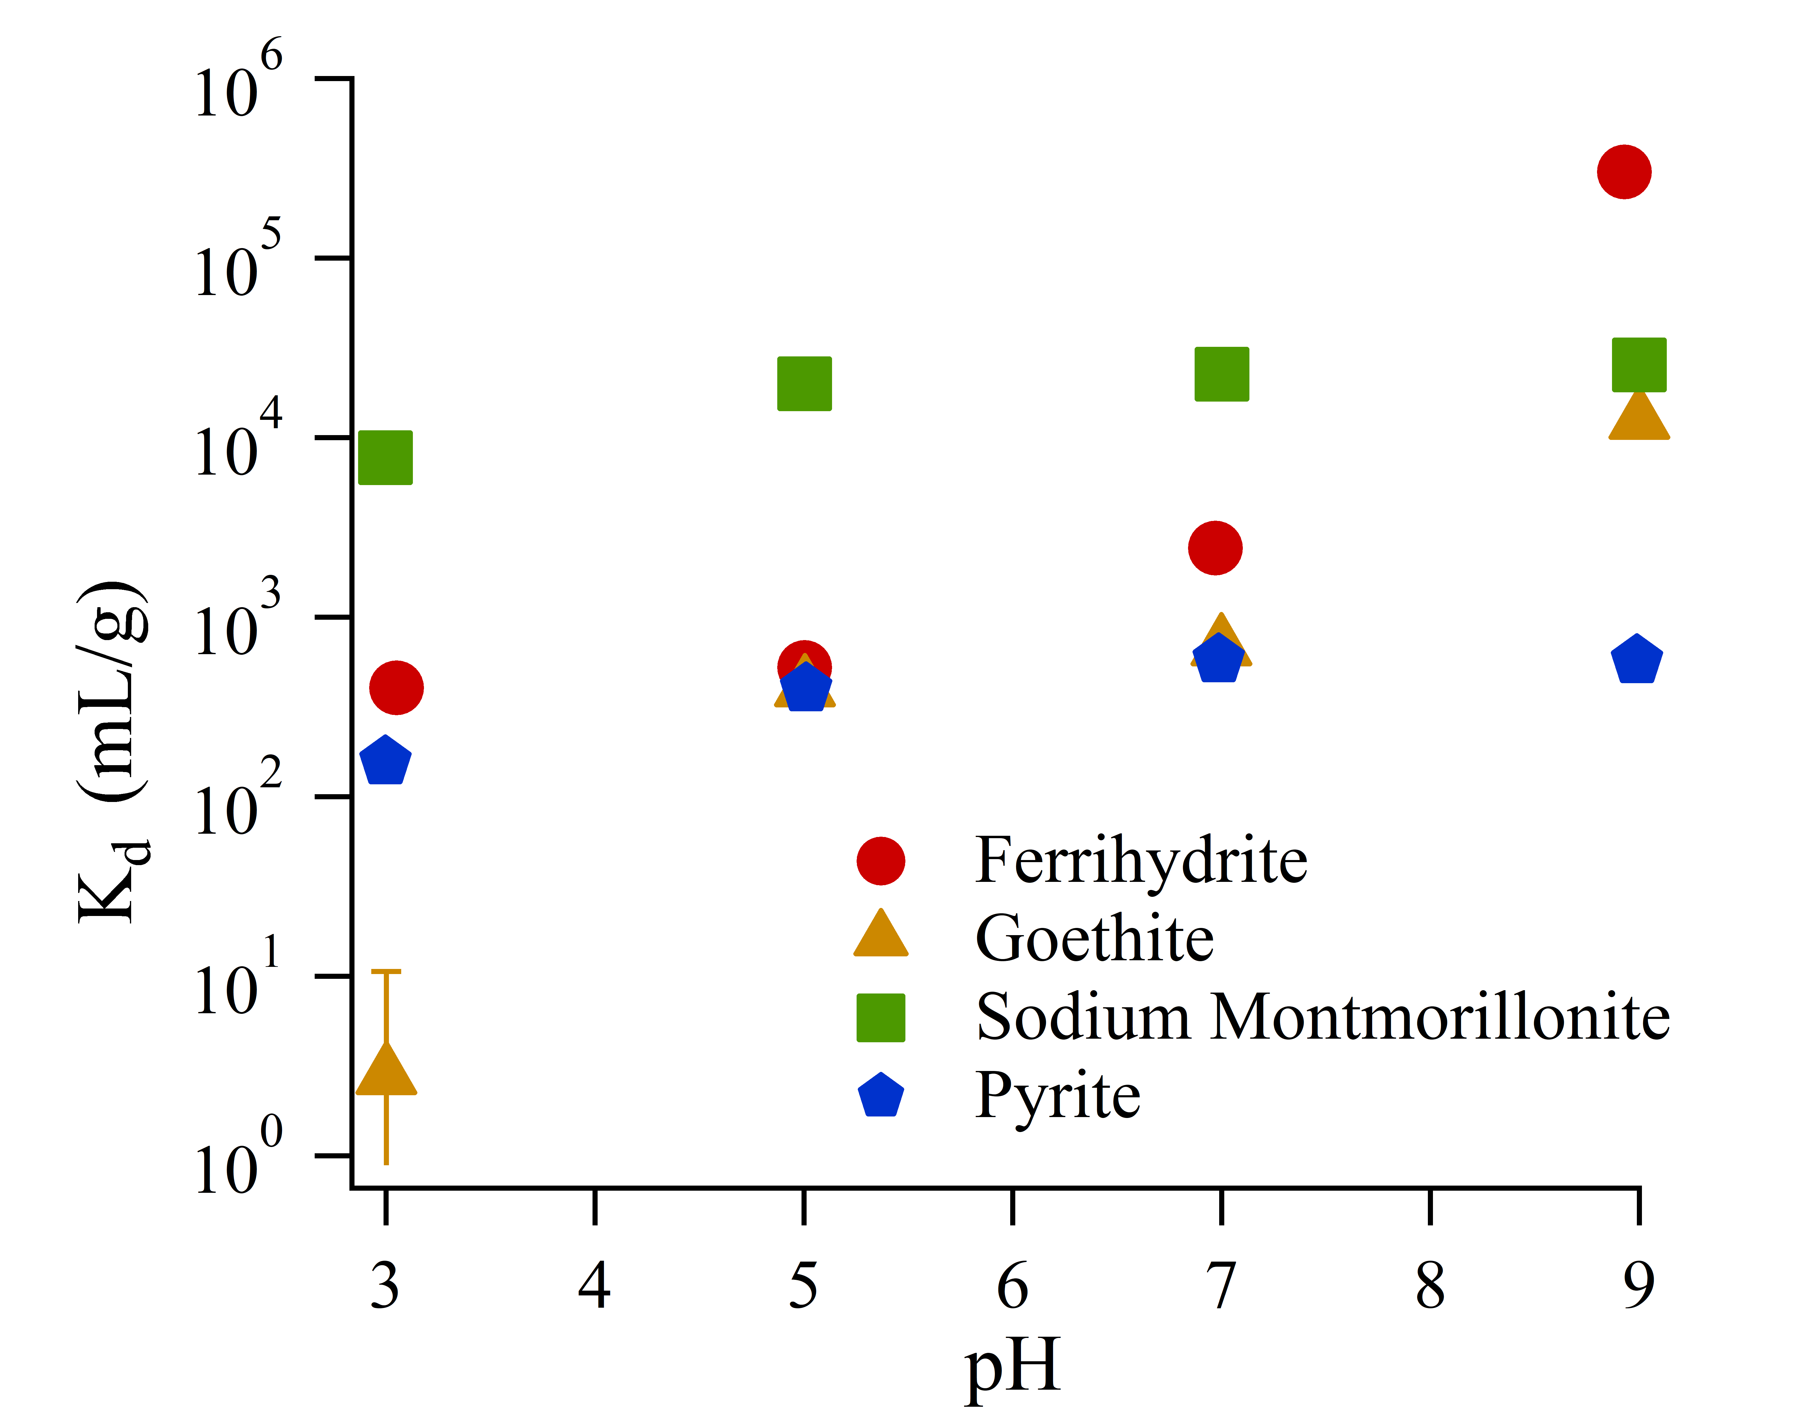

Figure 1: Sorption isotherm fits normalized by mass (left, figure 1a) or by surface area (right, figure 1b)



Figure 2: Impact of competing cations on Ra sorption (pH = 7, ionic strength for all solutions, I~10 meq/L).

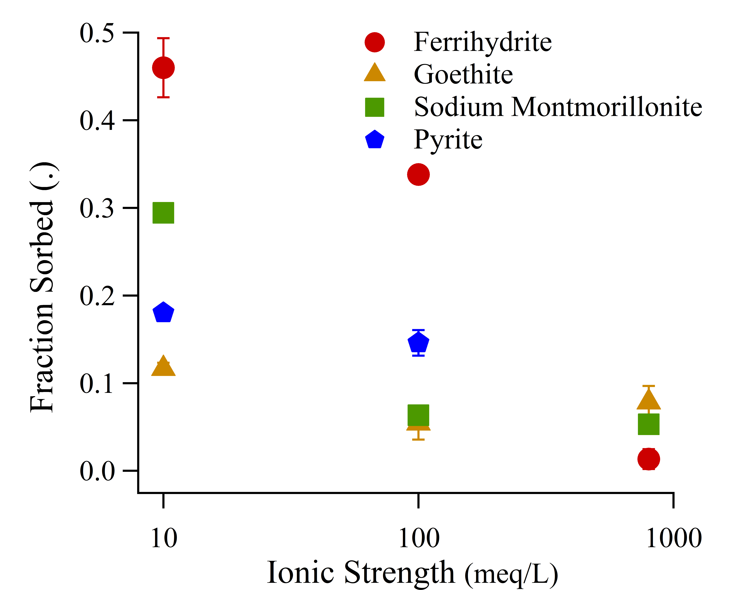Figure 3: Impact of ionic strength on Ra sorption (mixed cation solutions, pH 7).

|  |  |  |  |  |  |
| --- | --- | --- | --- | --- | --- |
| **Mineral** | **Reactions** | **Log K**  **Isotherm** | **Salinity RMSE** | **Log K**  **Salinity** | **Salinity RMSE** |
| Ferrihydrite | ≡FhysOH + Ra2+ ⇄ ≡FhysOHRa2+  ≡FhywOH + Ra2+ ⇄ ≡FhywOHRa2+ H+  ≡FhywOH + Ra2+ H2O ⇄ ≡FhywOHRaOH + 2H+ | 6.7  -2.8  -15 | 0.31 | 5.7  -11.0  -9.4 | 0.16 |
| Goethite | ≡GoeOH + Ra2+ ⇄  ≡GoeOHRa+ + H+  ≡GoeOH + Ra2+ ⇄ ≡GoeOHRa2+ | -3.9  3.5 | 0.16 | -2.5  -6.6 | 0.10 |
| Sodium Montmorillonite | ≡ClaysOH + Ra2+  ⇄ ≡ClaysORa+ + H+  ≡Clayw1OH + Ra2+ ⇄ ≡Clayw1ORa+ + H+ | 0.0  -2.1 | 0.38 | -0.9  -1.9 | 0.37 |

Table 1:Radium SCM reactions, fitted log K values from isotherm and salinity varied experimental data, and RMSE for fits to variable background cation solutions.

**Author Information**

**Corresponding Author:** Benjamin D. Kocar, 15 Vassar Street, Building 48-323. Department of Civil and Environmental Engineering, Massachusetts Institute of Technology, Cambridge, MA 02139. [kocar@mit.edu](mailto:kocar@mit.edu). 617-324-7746

**References**

(1) Zhang, T.; Gregory, K.; Hammack, R. W.; Vidic, R. D. Co-precipitation of radium with barium and strontium sulfate and its impact on the fate of radium during treatment of produced water from unconventional gas extraction. *Environ. Sci. Technol.* **2014**, *48* (8), 4596–4603 DOI: 10.1021/es405168b.

(2) Jones, A. P. Indoor air quality and health. *Atmos. Environ.* **1999**, *33* (28), 4535–4564 DOI: 10.1016/S1352-2310(99)00272-1.

(3) Ivanovich, M. Uranium Series Disequilibrium - Concepts and Applications. *Radiochim. Acta* **1994**, *64* (2), 81–94 DOI: 10.1524/ract.1994.64.2.81.

(4) Szabo, Z.; dePaul, V. T.; Fischer, J. M.; Kraemer, T. F.; Jacobsen, E. Occurrence and geochemistry of radium in water from principal drinking-water aquifer systems of the United States. *Appl. Geochemistry* **2012**, *27* (3), 729–752 DOI: 10.1016/j.apgeochem.2011.11.002.

(5) Barbot, E.; Vidic, N. S. N.; Gregory, K. B. K. K. B.; Vidic, R. D. R. Spatial and temporal correlation of water quality parameters of produced waters from devonian-age shale following hydraulic fracturing. *Environ. Sci. Technol.* **2013**, *47* (6), 2562–2569 DOI: 10.1021/es304638h.

(6) Vengosh, A.; Hirschfeld, D.; Vinson, D.; Dwyer, G.; Raanan, H.; Rimawi, O.; Al-zoubi, A.; Akkawi, E.; Marie, A.; Haquin, G.; et al. High Naturally Occurring Radioactivity in Fossil Groundwater from the Middle East. *Environ. Sci. Technol.* **2009**, *43*, 1769–1775 DOI: 10.1021/es802969r.

(7) Lauer, N.; Vengosh, A. Age Dating Oil and Gas Wastewater Spills Using Radium Isotopes and Their Decay Products in Impacted Soil and Sediment. *Environ. Sci. Technol. Lett.* **2016**, *3* (5), acs.estlett.6b00118 DOI: 10.1021/acs.estlett.6b00118.

(8) Grivé, M.; Duro, L.; Colàs, E.; Giffaut, E. Thermodynamic data selection applied to radionuclides and chemotoxic elements: An overview of the ThermoChimie-TDB. *Appl. Geochemistry* **2015**, *55*, 85–94 DOI: 10.1016/j.apgeochem.2014.12.017.

(9) Fesenko, S.; Carvalho, F.; Martin, P.; Moore, W. S.; Yankovich, T. Radium in the Environment. *The Environmental Behavior of Radium: Revised Edition*. 2014, pp 33–105.

(10) Gonneea, M. E.; Morris, P. J.; Dulaiova, H.; Charette, M. a. New perspectives on radium behavior within a subterranean estuary. *Mar. Chem.* **2008**, *109* (3–4), 250–267 DOI: 10.1016/j.marchem.2007.12.002.

(11) Beck, A. J.; Cochran, M. a. Controls on solid-solution partitioning of radium in saturated marine sands. *Mar. Chem.* **2013**, *156*, 38–48 DOI: 10.1016/j.marchem.2013.01.008.

(12) Schwertmann, U.; Cornell, R. *Iron Oxides in the Laboratary*; Wiley-VCH Verlag GmbH: Weinheim, Germany, 2000.

(13) Tamamura, S.; Takada, T.; Tomita, J.; Nagao, S.; Fukushi, K.; Yamamoto, M. Salinity dependence of 226Ra adsorption on montmorillonite and kaolinite. *J. Radioanal. Nucl. Chem.* **2013**, *299* (1), 569–575 DOI: 10.1007/s10967-013-2740-3.

(14) Sajih, M.; Bryan, N. D. D.; Livens, F. R. R.; Vaughan, D. J. J.; Descostes, M.; Phrommavanh, V.; Nos, J.; Morris, K. Adsorption of radium and barium on goethite and ferrihydrite: A kinetic and surface complexation modelling study. *Geochim. Cosmochim. Acta* **2014**, *146*, 150–163 DOI: 10.1016/j.gca.2014.10.008.

(15) Parkhurst, D. L.; Appela, C. A. J. *Description of Input and Examples for PHREEQC Version 3 — A Computer Program for Speciation , Batch-Reaction , One-Dimensional Transport , and Inverse Geochemical Calculations*; 2013.

(16) Python Software Foundation. Python Language Reference https://www.python.org/.

(17) Dzombak, D.; Morel, F. *Surface Complexation Modeling: Hydrous Ferric Oxide*; Wiley: New York, NY, 1990.

(18) Mathur, S. S.; Dzombak, D. A. Surface complexation modeling: Goethite; 2006; pp 443–468.

(19) van Geen, A.; Robertson, A. P.; Leckie, J. O. Complexation of carbonate species at the goethite surface: Implications for adsorption of metal ions in natural waters. *Geochim. Cosmochim. Acta* **1994**, *58* (9), 2073–2086 DOI: 10.1016/0016-7037(94)90286-0.

(20) The Clay Minerals Society. Source Clay Physical/Chemical Data http://clays.org/sourceclays_data.html (accessed Dec 10, 2017).

(21) Tournassat, C.; Ferrage, E.; Poinsignon, C.; Charlet, L. The titration of clay minerals: II. Structure-based model and implications for clay reactivity. *J. Colloid Interface Sci.* **2004**, *273* (1), 234–246 DOI: 10.1016/j.jcis.2003.11.022.

(22) Charlet, L.; Tournassat, C. Fe(II)-Na(I)-Ca(II) cation exchange on montmorillonite in chloride medium: Evidence for preferential clay adsorption of chloride - Metal ion pairs in seawater. *Aquat. Geochemistry* **2005**, *11* (2), 115–137 DOI: 10.1007/s10498-004-1166-5.

(23) Bradbury, M. H.; Baeyens, B. A mechanistic description of Ni and Zn sorption on Part II: modelling. *J. Contam. Hydrol.* **1997**, *27*, 223–248 DOI: 10.1016/S0169-7722(97)00008-9.

(24) Bradbury, M. H.; Baeyens, B. Modelling the sorption of Mn(II), Co(II), Ni(II), Zn(II), Cd(II), Eu(III), Am(III), Sn(IV), Th(IV), Np(V) and U(VI) on montmorillonite: Linear free energy relationships and estimates of surface binding constants for some selected heavy metals and actinide. *Geochim. Cosmochim. Acta* **2005**, *69* (4), 875–892 DOI: 10.1016/j.gca.2004.07.020.

(25) Michel, F. M.; Ehm, L.; Antao, S. M.; Lee, P. L.; Chupas, P. J.; Liu, G.; Strongin, D. R.; Schoonen, M. A. A.; Phillips, B. L.; Parise, J. B. The structure of ferrihydrite, a nanocrystalline material. *Science* **2007**, *316* (5832), 1726–1729 DOI: 10.1126/science.1142525.

(26) Cornell, R. M.; Schwertmann, U. Crystal structure. In *The Iron Oxides: Structure, Properties, Reactions, Occurences and Uses*; Wiley-VCH Verlag GmbH, 2003; pp 9–38.

(27) Ames, L.; McGarrah, J.; Walker, B. Sorption of trace constituents from aqueous solutions onto secondary minerals. II. Radium. *Clays Clay Miner.* **1983**, *31* (5), 335–342.

(28) Naveau, A.; Monteil-Rivera, F.; Dumonceau, J.; Catalette, H.; Simoni, E. Sorption of Sr(II) and Eu(III) onto pyrite under different redox potential conditions. *J. Colloid Interface Sci.* **2006**, *293* (1), 27–35 DOI: 10.1016/j.jcis.2005.06.049.

(29) Murphy, R.; Strongin, D. Surface reactivity of pyrite and related sulfides. *Surf. Sci. Rep.* **2009**, *64* (1), 1–45 DOI: 10.1016/j.surfrep.2008.09.002.

(30) Kornicker, W. A.; Morse, J. W. Interactions of divalent cations with the surface of pyrite. *Geochim. Cosmochim. Acta* **1991**, *55* (8), 2159–2171 DOI: 10.1016/0016-7037(91)90094-L.

(31) Wersin, P.; Hochella, M. F.; Persson, P.; Redden, G.; Leckie, J. O.; Harris, D. W. Interaction between aqueous uranium (VI) and sulfide minerals: Spectroscopic evidence for sorption and reduction. *Geochim. Cosmochim. Acta* **1994**, *58* (13), 2829–2843 DOI: 10.1016/0016-7037(94)90117-1.

(32) Naveau, A.; Monteil-Rivera, F.; Guillon, E.; Dumonceau, J. Interactions of aqueous selenium (-II) and (IV) with metallic sulfide surfaces. *Environ. Sci. Technol.* **2007**, *41* (15), 5376–5382 DOI: 10.1021/es0704481.

(33) Das, D. K.; Pathak, P. N.; Kumar, S.; Manchanda, V. K. Sorption behavior of Am3+ on suspended pyrite. *J. Radioanal. Nucl. Chem.* **2009**, *281* (3), 449–455 DOI: 10.1007/s10967-009-0030-x.